SDA LAB 6

S.M.Hassan Ali

K20-1052

**TASK 1:**

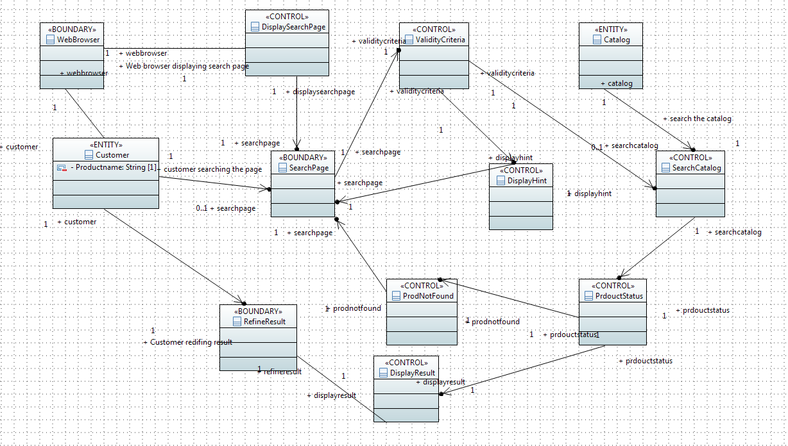

**TASK 2:**

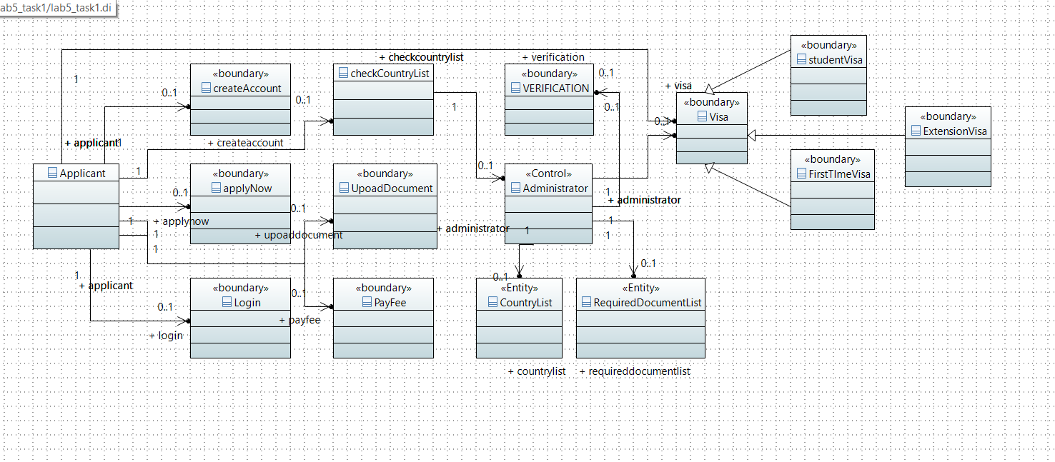

**TASK 3:**

**USE CASE NAME:** Prepare Question Bank

**Primary Actor:** Examiner

**Secondary Actor:** (can be system but not mentioned)

**Pre-condition:** To have questions available on computer or mobile devices

**Post-condition:** Question bank available for examination

**Trigger:** Clicking the use case

**Main Flow:** Defining exam patterns with questions banks

Choosing the appropriate questions

Compiling the questions to form Question bank

**Alternative:** Java/C++ questions can be set when choosing appropriate questions

**Exception:** Questions unable to be set while compiling

**Include: -**

**USE CASE NAME:** Prepare Examination

**Primary Actor:** Examiner

**Secondary Actor:** (can be system but not mentioned)

**Pre-condition:** Question bank available for examination

**Post-condition:** Student able to give examination

**Trigger:** Clicking the use case

**Main Flow:** Defining the exam pattern, objective in paper less manner

**Alternative:** Exam can be cancelled

**Exception:** Exam unable to cancel

**Include: -**

**USE CASE NAME:** Take Examination

**Primary Actor: Student**

**Secondary Actor:** (can be system but not mentioned)

**Pre-condition:** Student must be registered and must be logged in

**Post-condition:** Student able to give examination

**Trigger:** Clicking the use case

**Main Flow:** Register first

Then login

Take exam at the end

**Alternative:** Examination not available

**Exception:** Take Exam does not respond

**Include: -**

**USE CASE Name:**Review Examination Result  
**Primary Actor:**Student  
**Secondary Actor:** ---------  
**Pre-condition**: Exam given **Post-condition:**Exam Results are given **Trigger:**Clicking use case **Main Flow:**Login  
                   Check result

**Alternative**: ---  
**Exception:**Result not available **Include:**-

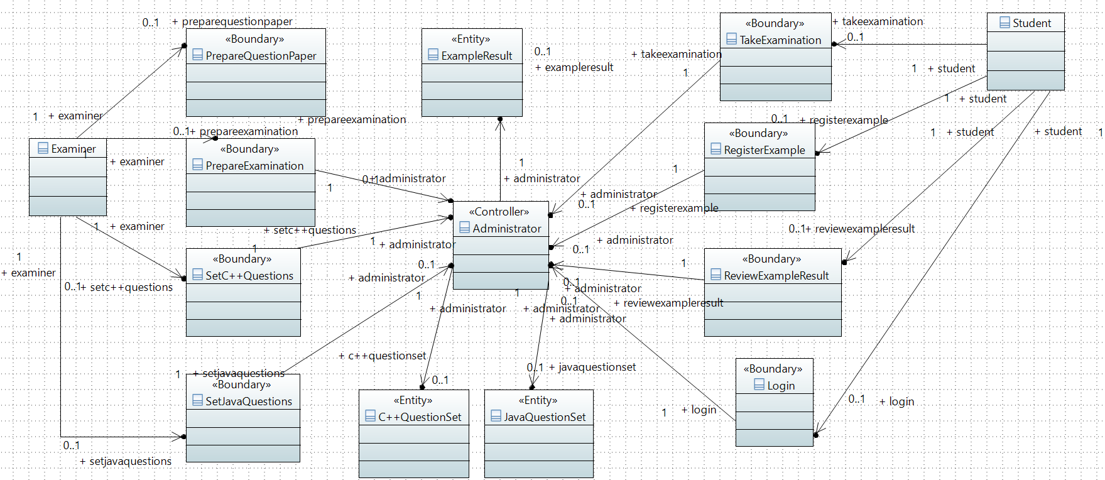



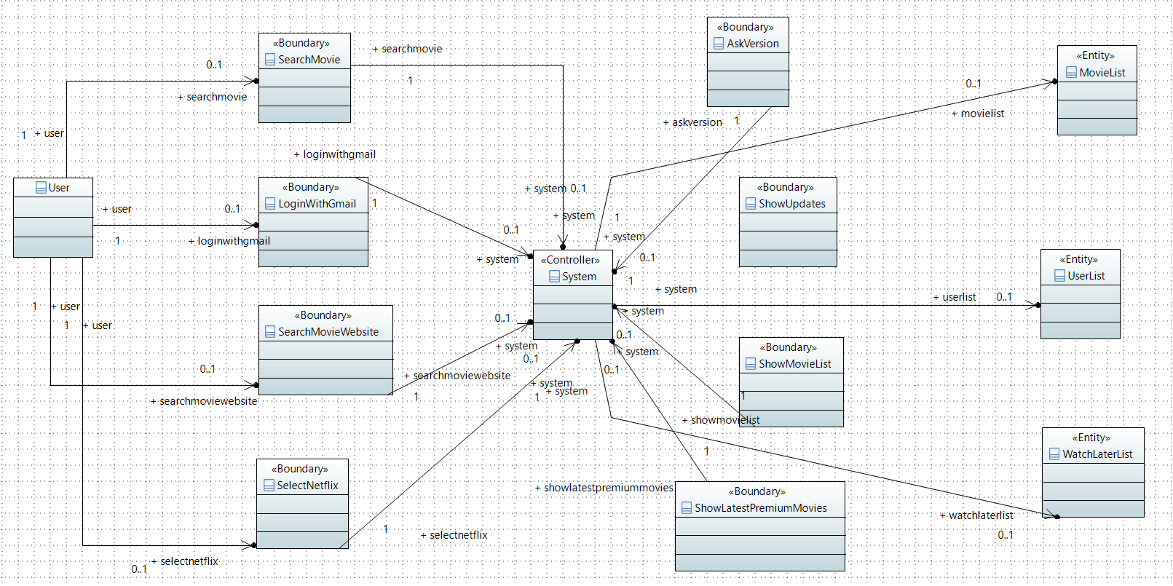**TASK 4:**

